EXPERIMENT – 3

1. View all the volumes in Docker

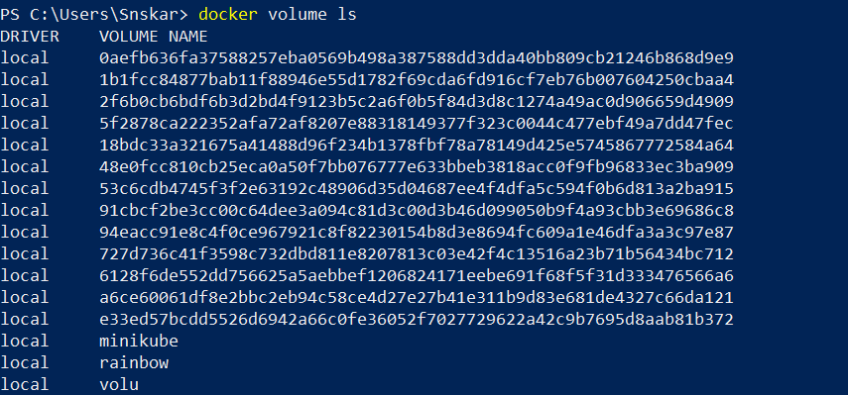

2.Create a new Volume



3.Mount a volume with a container

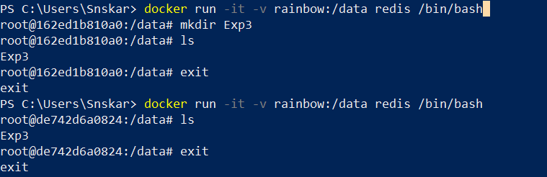

4.Create another container and mount with the same volume



5.See the working of the complete container

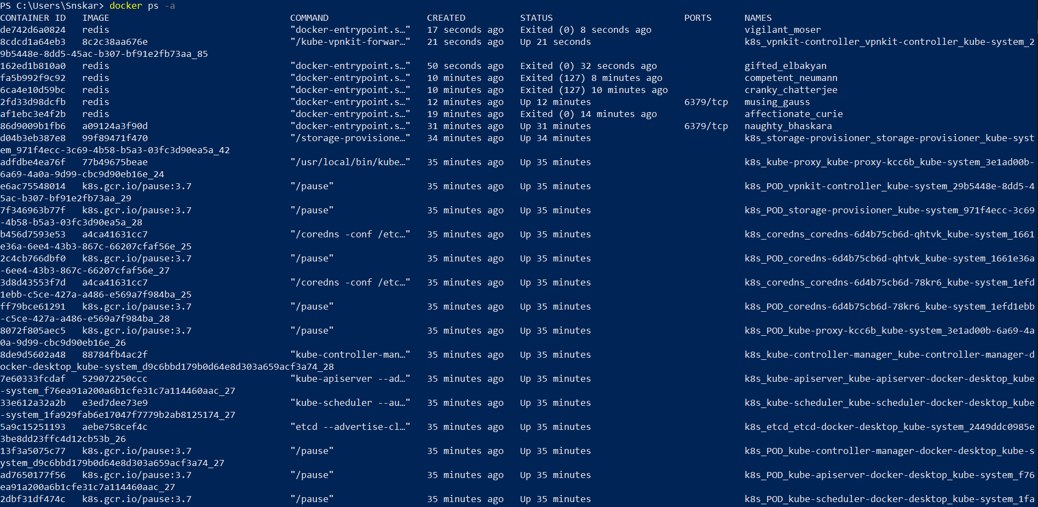

6.Exited the container and restart again to see the persistence of the docker volume

